Question 1: Write a function that has an input parameter and check if the input is divisible by 4.

Question 2: Write a program to check whether a given year is a leap year or not.

Question 3: Write a program to check whether a number is a multiple of 7s or not.

Question 4: Write a program to check whether a number is even or odd

Question 5: Write a program to find solutions for a quadratic equation

Question 6: Implement the Sigmoid, Tanh, and Softplus functions, described in slides 46, 47, and 50, respectively. You could use the examples in those slides as data for test cases. You need to do the docstring carefully.

Question 7: Re-implement the two programs in slide 63 using if-else instead of the switch.

Question 8: Write four functions for four approaches, described in slide 65
Question 1:
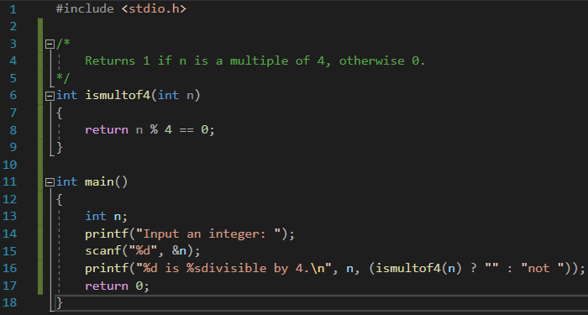
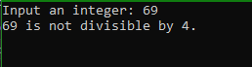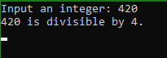

Question 2:
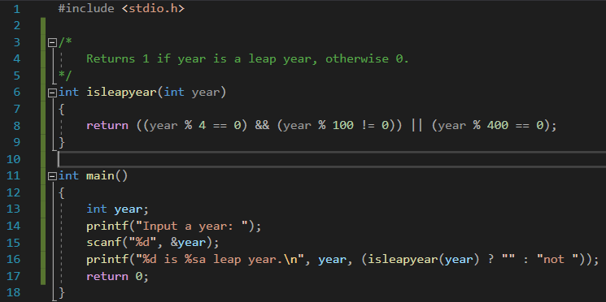
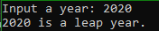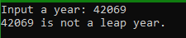

Question 3:
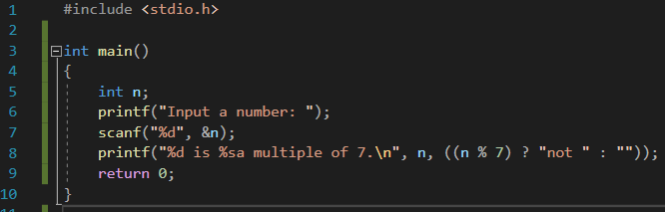

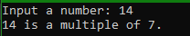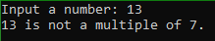

Question 4:
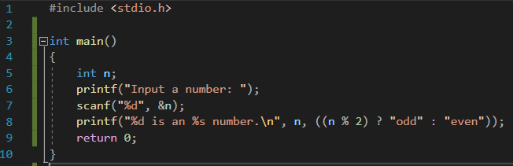

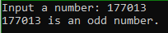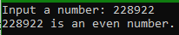

Question 5:
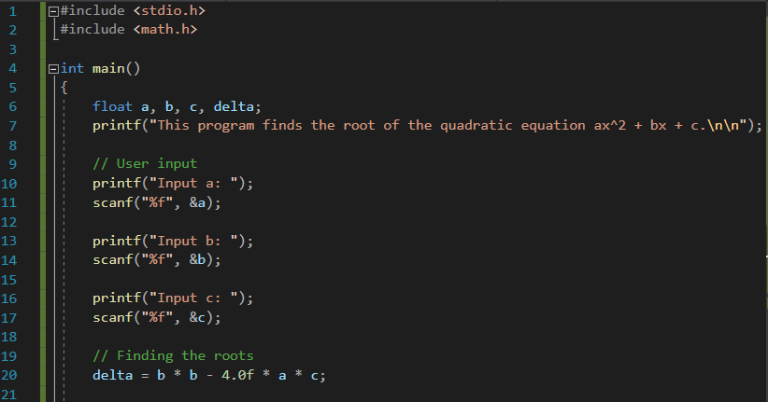
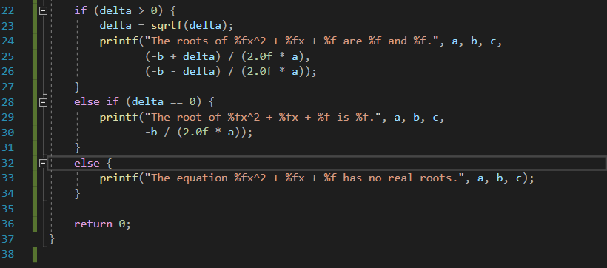

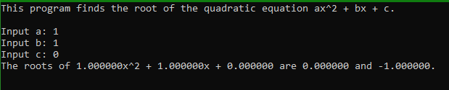
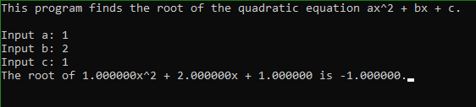
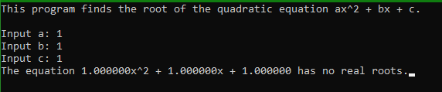

Question 6:
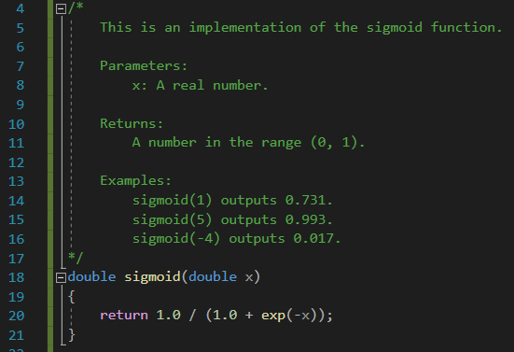

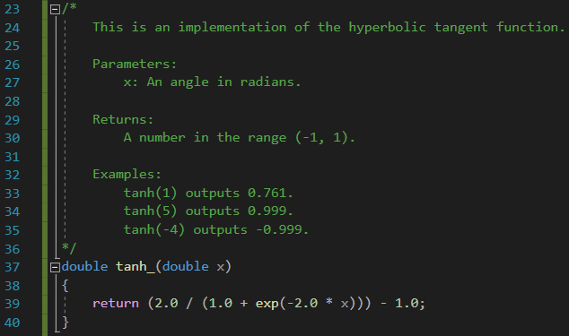
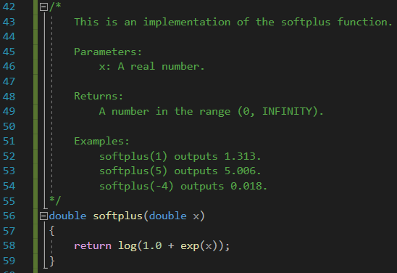

Question 7:
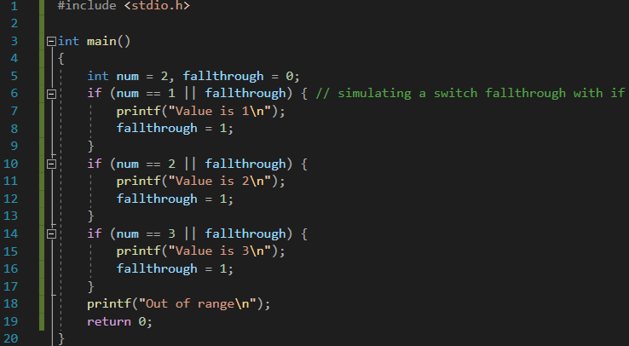

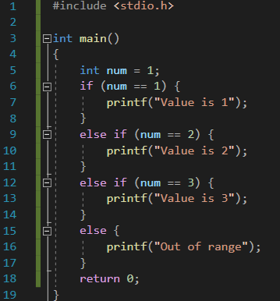

Question 8:
